# Project Name: Product Details Portal.

# Output:

### Landing Page:

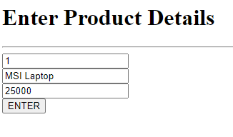

### Displaying Entered Product:

